OUR GUIDE TO
____________ CUISINE
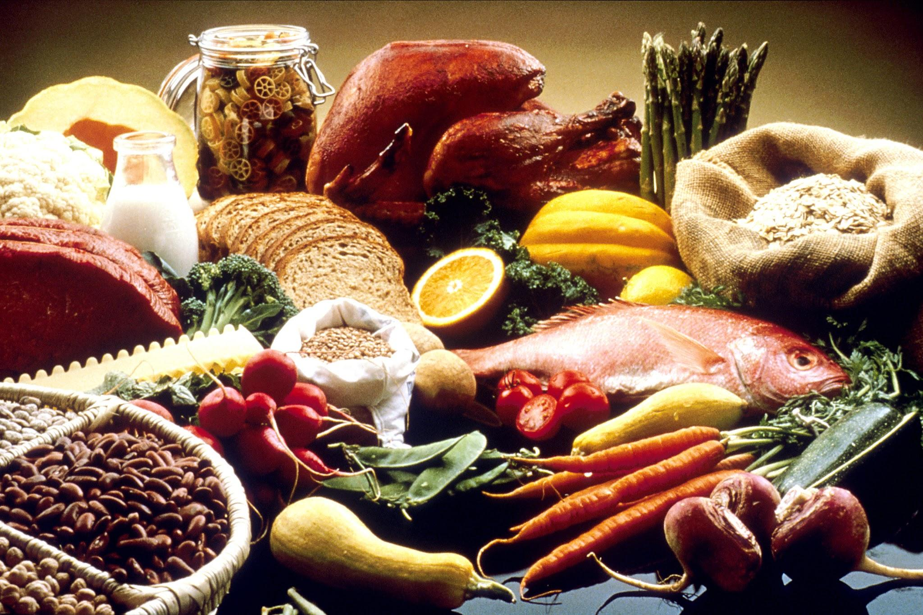

How to order…
_____________________________
(Do you have a table?)

_____________________________
(What do you want to drink?)

_____________________________
(Are you ready to order?)

_____________________________
(Do you have a kids menu?)

_____________________________
(I would like the…please.)

_____________________________
(The check please?)

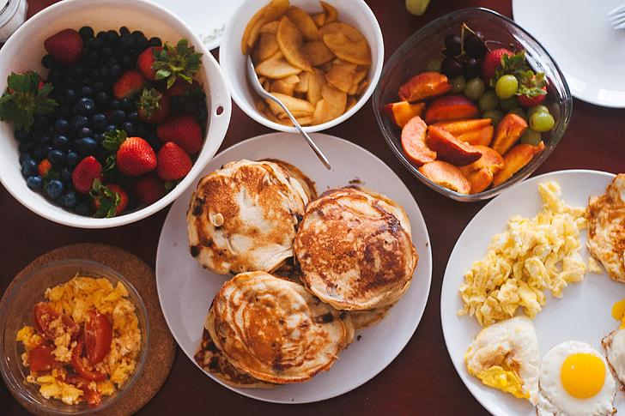

Popular Dishes

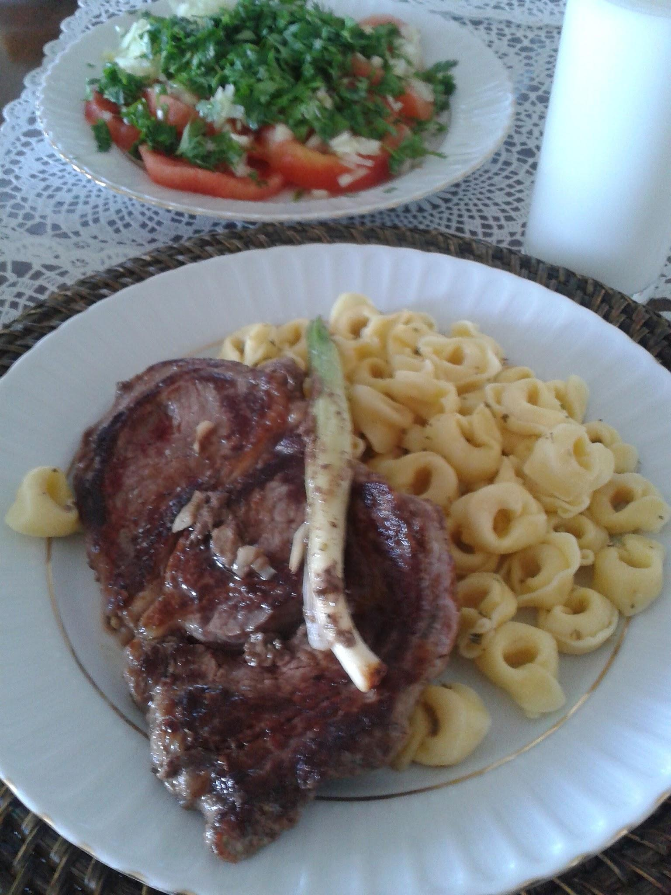
Dish Name description
Dish Name description
Dish Name description
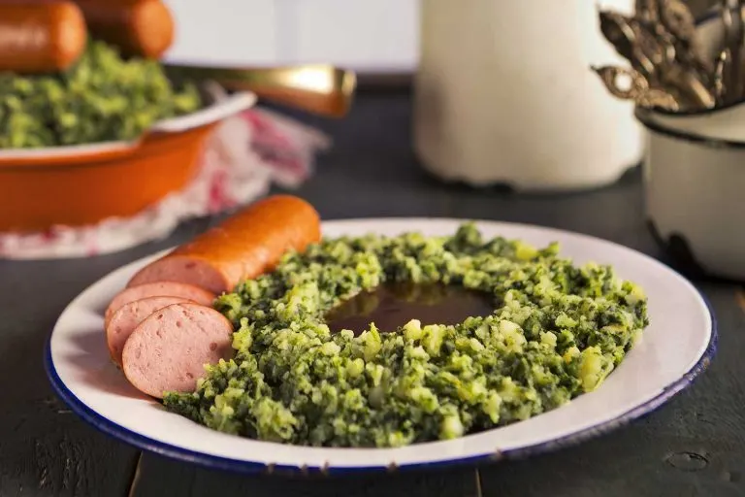
Dish Name description

Glossary
______ - Milk
______ - Eggs
______ - Mac & Cheese
______ - Gluten
______ - Baked
______ - Fried
______ - Roasted
______ - Spicy
______ - Pork
______- Beef
______- Chicken
______- Lamb

